Instrument and Sound Makerspace Lesson Spring 2017

Background: Students will be looking at the Midwest region of the United States and the impact it has had on different modern genres of music. They will further investigate what instruments are needed to perform the genre of music they have been assigned and create an instrument that can perform at least 2 different pitches.

SOL Objectives Covered in this Lesson:

Science 5.2 Sound (Students will investigate and understand how sound is created and transmitted, and how it is used.)

Social Studies 5.5 a &e The American Midwest Region of the United States (Students will learn about the states located in this region, as well as the representative landmarks and cities.)

Language Arts 5.9b Research (The students will find, evaluate and select appropriate resources to produce a research product/Collect information from a variety of resources. *Print/online/media.)

Music (Students will identify genres of music and look at the four main groups of instruments: woodwinds, percussion, brass and string instruments.)

Technology (Students will create a digital presentation about the city, genre of music and musical instrument they have researched. They can choose the technology medium of their choice to create the presentation. Examples could be: Prezi, Weebly, Educreations, Sway, etc.)

Setting the Stage: Students will work in small groups to focus on a city in the Midwest region of the United States and the impact that city has had on musical genres.

(Cities/Genres: Detroit, Michigan-Motown; Cleveland, Ohio-Rock ‘n Roll or R&B; Chicago, IL-Jazz; Minneapolis, MN-Punk Rock, St. Louis, MO-Blues)

They will focus on a particular genre of music and identify the prominent instruments used in that music. They will then design an instrument from one of the main groups: percussion, string, woodwinds or brass. This instrument will then need to function and adjust to show difference in pitch. Instruments will be constructed from makerspace materials. Students will create a short presentation to show what they have also learned about the genre of music and the city they researched about, as well as explaining the instrument they have made.

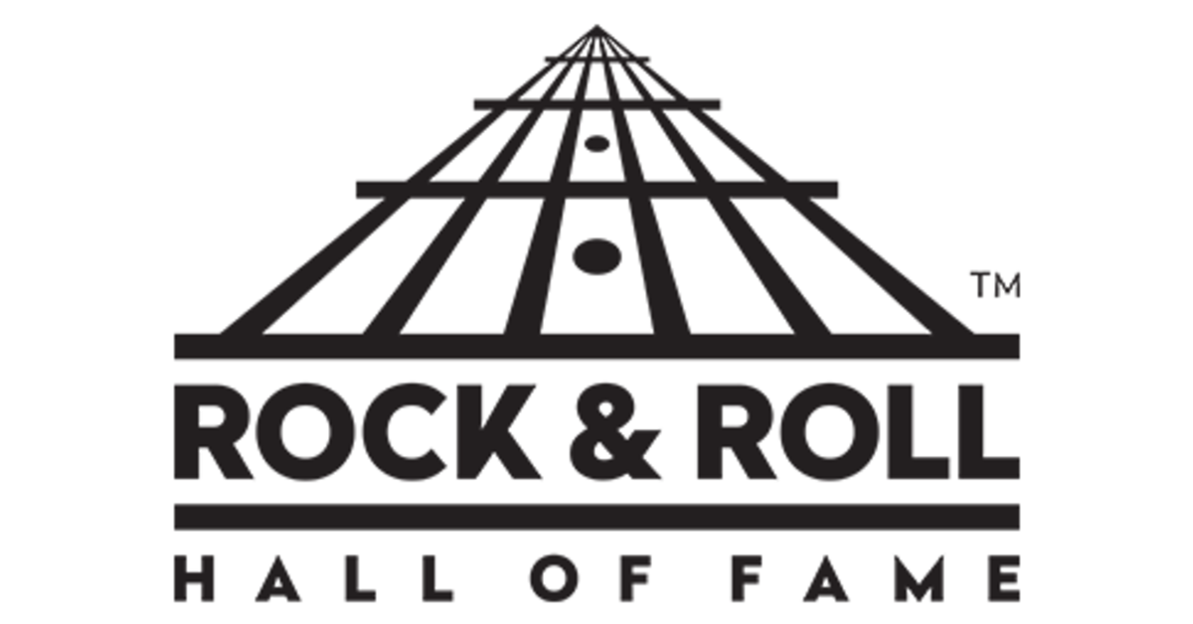

Musical Instrument Research & Design Brief

Goal: Create a technology presentation about one of the modern genres of music impacted by the Midwest region of the United States. Design a musical instrument that is from one of the main classes of instruments (string, percussion, woodwinds or brass) and used in your assigned genre that can change pitch.

Roles: Researcher and Engineer

Situation: Your class has been learning about the states in the Midwest region of the United States and some significant landmarks. One popular cultural destination for travelers is the Rock and Roll Hall of Fame in Cleveland, Ohio. You are going to further research the modern genres of music impacted by the Midwest region using print and online resources and then create an instrument that would have been used to produce one of those genres.

Requirements:

***Research the city and the music genre. Identify the instruments commonly used to perform that genre. Research some prominent musicians or musical groups that got their start in this area of the Midwest.
***Create a technology presentation with what you have learned.
***Sketch what your instrument will look like.
***Make a materials list from the Makerspace that you will need to build your instrument.
***Build your instrument and test to make sure that it can produce at least 2 different pitches.

Key Vocabulary:
1. Brass Instrument - A musical instrument that uses the musicians vibrating lips to produce sound. Does not actually need to be made of brass.
2. Percussion Instrument - Is a musical instrument that produces sound by being struck.
3. Pitch - The way we tell the difference between sounds. High pitch is synonymous with a “high” sound (soprano), while low pitch is synonymous with “low” sounds (bass). High pitch sounds have a higher frequency in their sound waves, while low pitch sound have a lower frequency in their sound waves.
4. Sound (Sound Wave) - Is a weak pressure wave which moves your eardrum which enables the brain to decode and allow you to perceive it as sound. It moves through the air like a wave does through water.
5. String Instrument - A musical instrument that uses vibrating strings to produce sound.
6. Woodwind Instrument - A musical instrument that uses the motion of blown air to produce vibrations, and thus sound. Does not actually need to be made of wood. Flutes and saxophones are woodwinds.
7. Vibration - The method in which sound is produced.
Instrument Performance Task Rubric
Objective | No evidence (1) | Little evidence (2) | Moderate evidence (3) | Significant evidence (4) | Total Points
Students designed an instrument on paper and created a materials list for their instrument.
Students researched the genre of music they were assigned and its’ impact on their city.
Students created a technology presentation that demonstrated their research knowledge on their topic.
Students built an instrument that represented their genre and performed at least 2 pitches.
Students could answer questions concisely about their presentation, instrument or research.
Total Maximum Points (20)

